March 31, 2025

Attorney General Pamela Bondi
U.S. Department of Justice
950 Pennsylvania Avenue NW
Washington, DC 20530

Dear Attorney General Bondi,

Thank you for the outstanding work that you and your team have been doing on behalf of our nation.

We also thank you for your attention to the outrageous ballot fraud in Connecticut.

We write today with regard to the pending appointment of a U.S. Attorney for the District
of Connecticut.

Connecticut deserves an aggressive, vigorous and vocal Republican U.S. Attorney who shares
our values.

We continue to call out the rampant and alarming waste, fraud and abuse in Connecticut government, but as a super minority party here in Hartford, Connecticut Republicans need all the help we can get from your office.

The appointment of a Republican U.S. Attorney for the Constitution State cannot come soon enough as far as we are concerned.

Thank you in advance for your attention to this appointment which has the potential to help Connecticut immensely. Please let us know if there is anything we can do to expedite the process.

Sincerely,

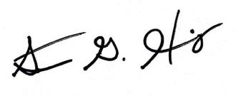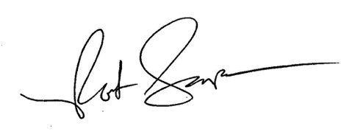
Stephen Harding Rob Sampson

